

*All for The University of Sydney*

Bingyan Chen|Haochen ZHANG|kaijun peng|Liuyu|Jackson wang

480049942| 490169971| 490441372| 490095315| 480342832

Website Development Project

RE03_Group4

*Students*

Contents

Introduction 3

Overview 4

Phase 1 User Investigation 5

Team Evaluation 5

Team-based persona 5

User Evaluation 6

Survey-based User persona 6

Phase 2 Navigation design 8

Card sorting 8

Information architectures 8

Phase 3 Iterative design 8

Prototype 1st iteration 9

Initial prototype user evaluation result 9

First usability testing 9

Prototype 2nd iteration 12

Second usability testing 12

Interview 14

Prototype 3rd iteration 15

Conclusion 17

Limitations 17

Achievements with respect to project requirements 17

Appendix 18

Appendix A – content reference 18

Appendix B – PACT analysis 19

Appendix C – survey result 19

Appendix D – card sorting result 22

Appendix E – wireframe 23

Appendix F – First usability testing 24

User - Estelle Wang 24

User - Encheng Qu 26

User - Shiyuan Li 28

User – Tony 30

User - Xiwen Zhang 32

Appendix G – First usability testing 34

User – Venna 34

User - Christine (Yuwei) 36

User - Irene Qu 38

User - Sijia Yu 40

User – Gaohao ming 42

Appendix H – PACT Analysis 44

Appendix I – Graphical representation of group’s journey 44

# Introduction

In this project, various techniques and tools are utilized to understand and develop an outstanding project. Below are the detailed descriptions for each tool.

Figma is a prototype design tool that runs on the cloud. In theory, as long as the internet is connected, it is available to anyone on any device. It has several advantages compared to other prototype design tools. Firstly, it is fast. The biggest pain for other tools is that they are easy to crash if the design files are slightly larger. However, our group has never encountered such a serious situation. Besides, it supports multiplayer online editing at the same time. This is almost the most important function of Figma. Since this is a group project, every team member needs to contribute to the design. It can subvert the original digital product design process and mode, which disclose the originally invisible design operations. It can greatly reduce the cost of communication within each team member and can quickly collect feedback. Lastly, Figma combines feathers from other tools. Figma is more than just a prototype design tool, its functions have almost covered all important steps in digital product design. For instance, our team can use Figma to complete the design, then make an interactive prototype and collect feedback through evaluations. These steps can be completed only by relying on Figma.

As for the communications between team members, our team relies on WeChat and Zoom. WeChat supports various platforms (e.g. IOS, Android. etc.) to quickly send text and voice messages through the network. Since all our team members are overseas now, WeChat is the best option for daily communication and getting quick responses. Our team communicates daily through WeChat and asks for feedback and answers if we are not sure about certain questions.  Zoom supports free cloud video conferencing both on PC and mobile platforms among diverse people. We use Zoom for our weekly meetings to communicate about what progress to be made and any questions to be solved.

Google Docs is an online document that can be edited by multiple people at the same time, supporting online Word or PDF, which can be viewed and modified anytime, anywhere on the computer, iPad, and other types of devices. The document can be viewed and edited as long as the webpage is opened and saved in the cloud in real-time. Our team uses it to write documentation such as meeting minutes. Google Forms is a survey management application that lets users investigate and collect information from others. Besides, Google Forms also supports multi-user collaboration and sharing functions. In this project, before developing actual software, our team launches a survey to investigate who are the target users along with their characteristics for the software and what functions are useful to them.  Google Chrome is a web browser which is used to search and gather relevant information from various sources.

Goodnotes and Notability are two software tools for taking notes on iPad. Since all team members have an iPad, we select this software to take some quick notes during tutorials and meetings. Besides, some initial design ideas are drawn using the software.

## Overview

Below is the lifecycle diagram of our design process.

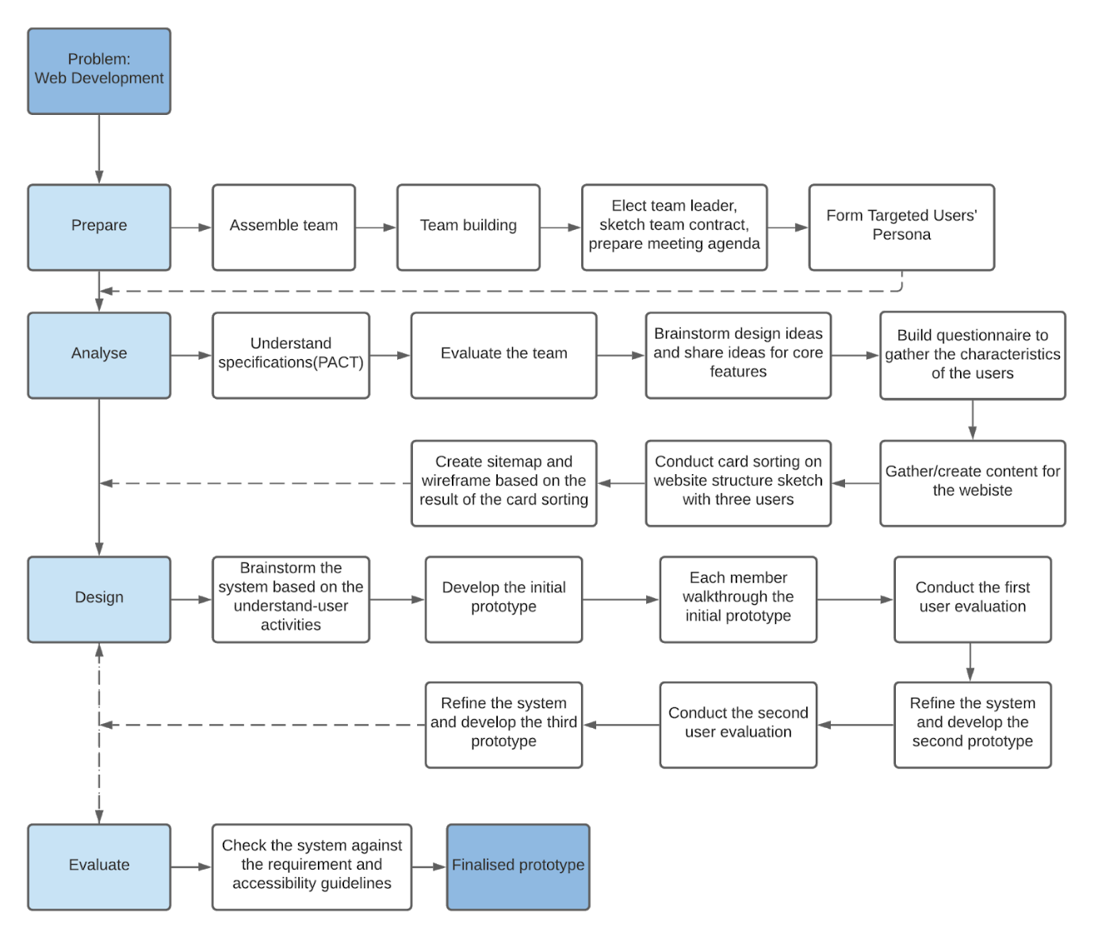

And the following is the task with its appendix reference.

|  |  |
| --- | --- |
| **Task** | **Appendix Reference** |
| PACT analysis | - |
| Team persona | - |
| Investigation protocol | - |
| Implications of PACT analysis | - |
| Card sorting | D |
| Wireframe | E |
| First usability testing | F |
| Second usability testing | G |
| Graphical representation of group’s journey | I |

Our website design procedures are designing our persona first, then we make a survey. After gathering the data, we design the website wireframe and sitemap. Then we finish our prototype and refine the prototype iteratively according to the comments from user evaluation.

Next, we will introduce each process undertaken by our group in order.

# Phase 1 User Investigation

To better under the users’ need, the team apply the PACT analysis technique and it could be found in Appendix H for further reference.

PACT helps the team in the following phases in several ways. Since the design of UX is related to human characteristics in many ways. PACT analysis can help designers to get a full map of what factor of human will impact the interaction between human and computer(system).

People differ in terms of physical and psychological qualities, as well as in how they use systems. Activities differ in terms of timing, complexity, safety, and the type of content required. Physical, legal, and organizational characteristics of contexts differ. The input, output, communication, and content that technologies support is all different.

The established PACT result reminds the team of the true user needs in the broad sense. It ensures the team is on the right track when the team brings up in-depth designs or there is a dispute.

## Team Evaluation

### Team-based persona

|  |  |
| --- | --- |
| **Attribute** | **Value** |
| Name | John Columbia |
| Age | 22 (Second Year) |
| Gender | Male |
| Background | Grew up in ACT |
| Course (Degree) | Bachelor of Advanced Computing |
| Knowledge/Interests | Video games, Diving, racing car, Singing |
| Skills | R studio, Java, Python, SQL |
| Goals | HD mark  Web design/development |

## User Evaluation

We use the google form to make our questionnaire. Then we distributed the questionnaire across our network to analyse and learn our target users' group. The questionnaire was launched on March 13th, and we were unable to complete it until March 18th due to continuous submissions. Additionally, the project's key criterion is to teach "every University of Sydney student," and data reliability has a good association with the size of the experimental community, so those two considerations are also taken into account. Further reference could be found in Appendix C.

The team developed and accepted the questionnaire. It is made up of demographic questions, such as: e.g. How old are you, Do you have IT background, and behaviour questions e.g., what are you expecting from the website? These behaviour questions would help the team to design to fit the user's needs.

The results show that 71.3 percent of our respondents have an IT history, while 28.3 percent do not, which is possibly biased because we only sent the questionnaire to friends and acquaintances. Some respondents shared curiosity in Python bottle, JavaScript, and HTML tutorials, whilst others lamented their lack of CSS and Framework awareness. In terms of content delivery, video plus text came out on top by a wide margin. Users come to our website for a variety of reasons, which reminds the team to diversify the content. Finally, 79.2 percent of respondents requested multilingual assistance.

The team realized questions may have left open-ended responses for respondents when reviewing, because the choices given could be limited, especially in the question, "What is your purpose for using our website?" There should be more demographic questions, not just technological, behaviour questions, to get a better picture of users' profiles.

The user persona below is generated based on the summary of the collected submissions.

### Survey-based User persona

|  |  |
| --- | --- |
| **Attribute** | **Value** |
| Name | Stella Lau (she/her) |
| Age | 21 (Second Year) |
| Gender | Female |
| Background | Born and grew up in Sydney |
| Reason for choosing USYD | Like all the societies on campus |
| Likes about USYD | Water bubblers |
| Dislikes about USYD | People sleeping in the library |
| Program of study | Advanced Computing (Data Science, Computer Science) |
| Favourite unit of study | INFO1113 |
| Personal challenges | Long commute |
| Career goal | Financially independent + self-employed |
| Plans after graduation | Full-time work |
| Goals | Prepare for a job, learn to develop websites and be proficient |
| IT Background | Yes |
| Expectation about the website | Python bottle |
| Preferred learning methods | Text and video |
| Special requirement | Multi-language support |

# Phase 2 Navigation design

## Card sorting

We divided our sort into two parts, one of them is our website-function-oriented card sorting, another one is the card sorting about programming knowledge.

The programming knowledge part achieved 100% agreement about the card sorting. The specified knowledge about HTML, Python Bottle, CSS and JavaScript will be assigned to HTML module, Python Bottle module, CSS module and JavaScript module respectively.

Closed card sorting

Open card sorting

In order to keep consistency on the overall website, the team decided to have the same heading for our website.

We brainstormed a list of question/content that users may have whilst using the website. The questions are divided into two section, one open card sorting and one closed card sorting. The open card sorting is designed to observe that how users perceive the different course content e.g., python bottle, python syntax, JavaScript structure and JavaScript syntax. The closed card sorting is designed to categorize the website content and functionality e.g., FAQs, profile page, discussion channel, in the perspective of users, to construct the navigation system for the website.

## Information architectures

After having the website navigation, the team started our design of wireframe and sitemap.  We discussed the functions and pages we need in our web, and that consists of account page, course page, forum page, feeds page, message page, log in(up) and so on. Then everyone draws one- or two-pages’ wireframe. In the next zoom meeting, everyone shows their wireframe, then combines the advantages of each wireframe and draws a final one together. Sitemap is based on the wireframe, each page is a block in the sitemap, and then discusses the connection of each block.

The sitemap and wireframe are the exact reflection of user needs. It is designed based on the result of user card sorting and brought a sketchy layout of the website. Besides, further iterative improvement and implementation is needed.

# Phase 3 Iterative design

As the final output of the whole design process, the team decided to conduct iterative prototype design, which consists of three iterations of prototype and two usability testing in between. Before we design the initial prototype, each team member collects good design websites, and we discuss the style that benefits us. And style final decided is simplicity and the colour should be light, since the light colour and the contrast design could make the user feel comfortable. Then everyone draws the same pages as the wireframe. Course pages are the core pages. The resources we use in the website are picked from the internet, and further reference list could be found in Appendix A. The team constructed a protocol to ensure the quality and reliability, which could help users study easier.

Usability testing is a crucial part of the project, which could effectively evaluate the quality of the prototype. The team as designers, sometimes might have some bias to our own prototypes. We feel everything is perfect and can’t find some defects. But when participants run our task, the problems can emerge immediately. Thus, we try to make the task complete which could include all the operations our prototype can. And after the reflection has been collected, the team will try to fix the complained problems and adopt the proper and reasonable suggestions into the next iteration of the prototype.

## Prototype 1st iteration

We adopt the same style as Ed. If we want to prove user usability, Simplified operation is needed. So, we design a main bar, it likes navigation. Users can view any core pages by clicking the icon in the main bar. And we draw the main bar together and add some simple icons. To clean the ambiguity of the icon, we group up the words and icon, and the main bar includes account, course, forum, feeds, message, and our website symbol. At this stage, we focused on implementing all required student functions. And in any page, we only add the necessary image and words to reduce the time to find information.

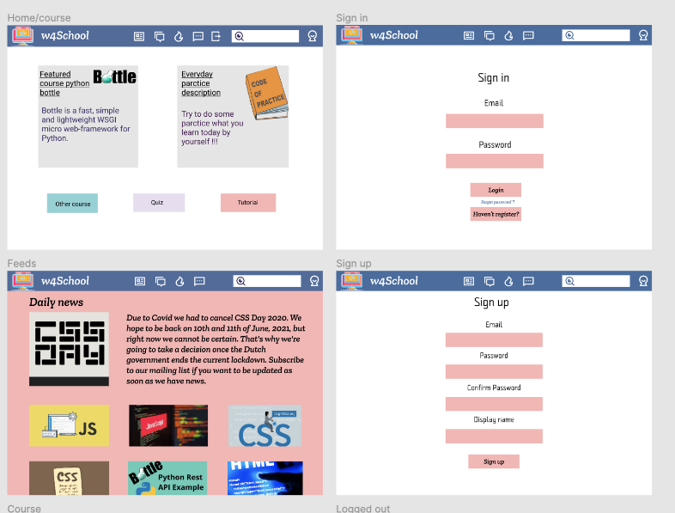

### Initial prototype user evaluation result

We as a team conducted cognitive walkthrough after designing. We cannot identify any issues since the whole system was all designed by ourselves, but it turned out as problematic design and logic in the usability testing.

### First usability testing

The responses have been summarized in the table below.

|  |  |  |  |
| --- | --- | --- | --- |
|  | **Pages** | **User Response (Any issues?)** | **Additional Comments** |
| 1. | Sign up | Better change words “email” to “username” |  |
| 2. | Log in | None | Email login might be too long, we could use unikey |
| 3. | View Bottle course | None | The font too big, Bottle image could be smaller |
| 4. | View JavaScript course | The size of the font in the menu is too small | ·   Image could be set in higher resolution  ·   It will be better if the menu can be hided.  ·   The button of the course like a course schedule, poor pick |
| 5. | View HTML practice | None | There are only questions without any tutorials. |
| 6. | View Python practice | The size of the font in the menu is too small |  |
| 7. | Message a user | Can’t use the message since I can’t type a word or DM with others and cannot make a group talk. | Should improve this function and make DM achievable |
| 8. | View message history | Task set inappropriately since there is no message listed |  |
| 9. | View Forum | None | Filter is not clear |
| 10. | Manage profile | I can’t manage my profile, but I can check my profile | * Font could be improved * Allow user to manage profile |
| 11. | View Feeds | I can see the feeds, but I cannot click on them | * Allow users to check multiple feeds * The button of feeds is too ambiguous |

#### Interview

*General opinions*

* Other course in the course page is confusing, there are four links to one page. They can be combined, which will save place for another potential functional button. Featured courses other courses could be put in one page with featured courses prioritized.
* Course Page needed be improved, cannot find what I need in time and effectively.
* Pretty good about log in and create account and also seeing course but the other functions are seemed not prepared enough.

*Suggestions*

* Subscribe button in Feeds.
* Better aesthetic design
* Back button

In the summary above, most of the participants addressed that the login, sign up page are well designed. The main issue is that the *other course* button in the course page, which was complained by the participants the most. Other issues include the unimplemented functionality in the message page, image resolution, font issues and other aesthetics issues.

Although this, the participants commented highly on the messaging image, audio chat and video chat functions, but that would be just some sweet only in prototype, whether implement was yet to decide.

Whilst we gather the feedback of the first prototype, some of the participants advised that go-back button in course page, which will be considered in the actual implementation but not in the prototype iteration as its practicality. Another insightful suggestion is share function in feeds page. That will be considered in the implementation as the project prohibits the use of CDN and external resources.

Based on the feedback we got above, the following tweak will be applied in the next prototype:

* Redesigned website header with text descriptions.
* Redesigned course with clearer layout.
* More animation on messaging page.
* ‘Update password successfully’ pop-up window after update password.

# Prototype 2nd iteration

After the first user evaluation, we discuss the comment of the participant, and adopt some good ideas. The obvious change is grouping up with words and icons. In participant comments, most of the participants confuse the icon. When they do the task, they can’t identify the forum and message. So, we add the words to help people view different pages easier. The first iterative course design is so weak, so we also upgrade the course pages. In the first iterative course, if we want to view a course, we have to click the button on the home page to course pages. But in this iteration, users don’t need this process anymore, it can save some time.

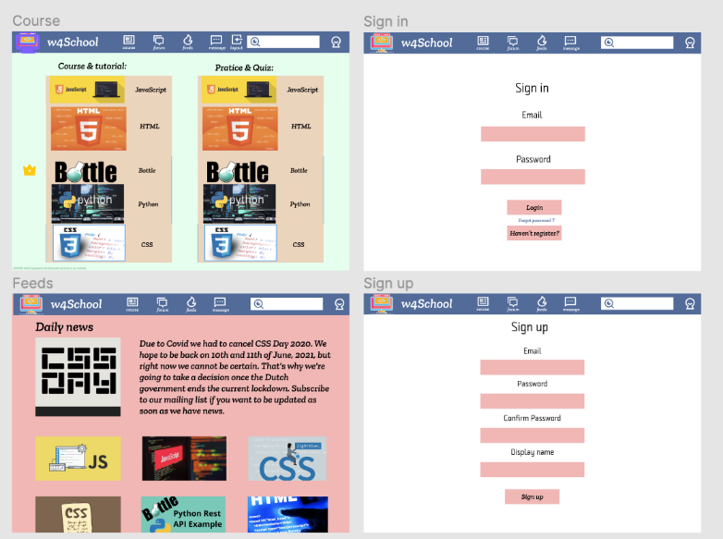

## Second usability testing

The second usability testing template inherited the test plan from the first usability testing. And it is summarized below.

|  |  |  |  |
| --- | --- | --- | --- |
|  | **Pages** | **User Response (Any issues?)** | **Additional Comments** |
| 1. | Sign up | None | ·   It is good. But what does a resetting password need? Feel like only a security question is not enough….  ·   Font size seems too large |
| 2. | Log in | None |  |
| 3. | View Bottle course | None | I have looked at all the courses and practices. It is well formatted. |
| 4. | View JavaScript course | None | Navigation has the same background colour with content |
| 5. | View HTML practice | None | ‘Practice & course’ could be larger to draw more attention |
| 6. | View Python practice | None |  |
| 7. | Message a user | Unable to type in anything yet | ·   Add friend button in channel page could be improved  ·   Users’ icon can be shown in the contact’s list.  ·   Page 7 is so big that it cannot display on my side, even when I tried to zoom out. |
| 8. | View message history | None |  |
| 9. | View Forum | The layout is good, but not able to switch to other forum windows | The comment box is a bit small compare to the content part. Users may feel uncomfortable if they want to type in long contents. |
| 10. | Manage profile | The ‘upload pic’ option is not available | ·   Has a little issue on locating  ·   The ‘Moments’ section is unmeaningful, no explanation.  ·   Safety should in the setting |
| 11. | View Feeds | None | Need a record and load button to feel more natural |

## Interview

*General opinions*

* The font size of pages is not consistent, may cause users hard to read.
* The contents/icons of course & quiz home page seems a bit overlapping. Maybe try to use only one icon for each programming language and give choices for course and quiz under each language.
* The icons of user can be added to the contacts list of chatting window, so that users can distinguish people easier.
* Navigation has the same background colour with content some backgrounds colour should be changed, light colour could be better

*Suggestions*

* Share function with website screenshot downloaded or Website bookmark

The second usability testing look in depth of the second prototype. The positive comment significantly increases compare to the first prototype. Overall, the participants are satisfied with the intuitive navigation bar, course content page and login page. Besides, the participants pointed the design flaws in helping text, buttons, account profile pictures, and consistence.

Based on the above usability testing, the team decided to have the following improvement in the next prototype:

* Improve interaction in the forum and messaging page
* Redesign course page
* Refine overall aesthetics setting includes colour theme and page layout
* Enrich interaction in admin page

# Prototype 3rd iteration

And this is our final version prototype, we upgrade many details to improve beauty. And add many pages which can show functions more clearly. This prototype also clears many mass parts.

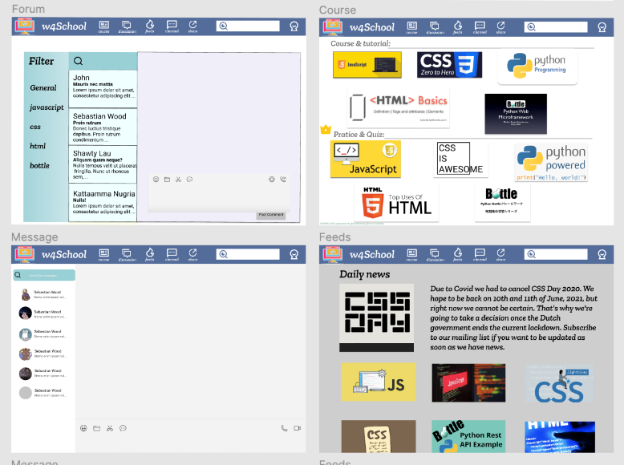

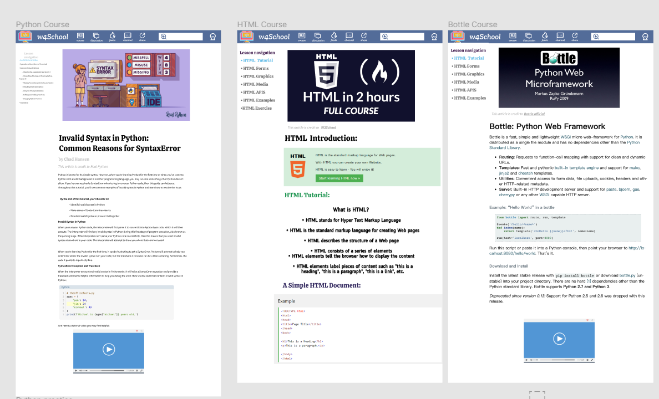

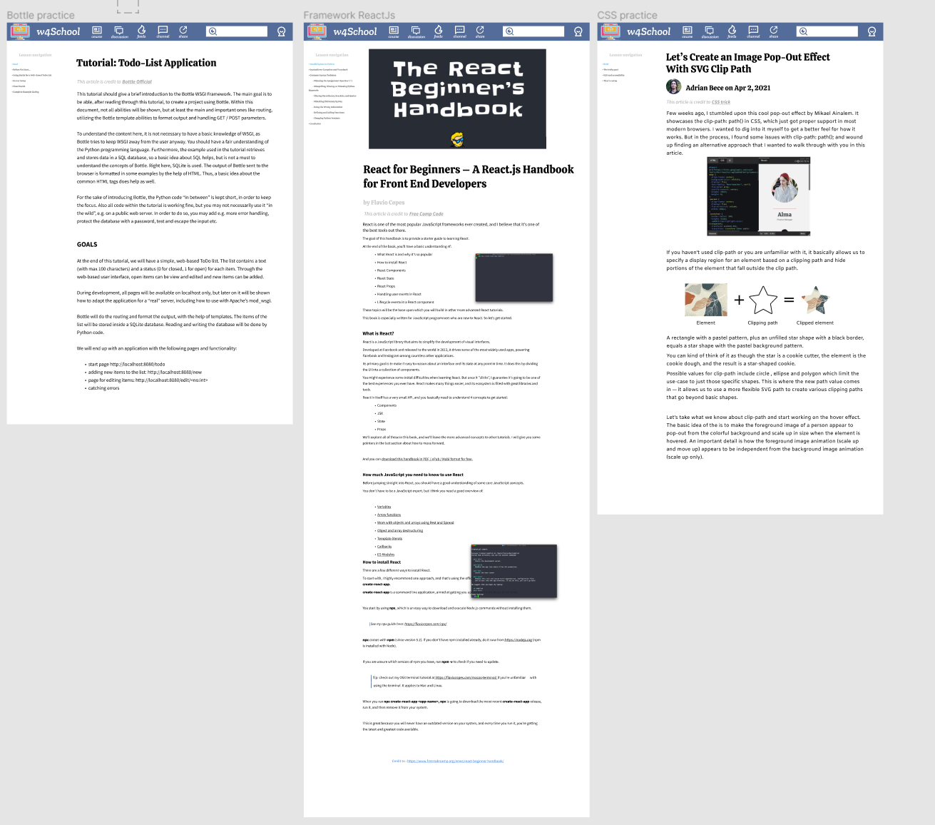

# Conclusion

## Limitations

There are still some imperfections in the project. Since this project is implemented on Figma, some operations cannot be presented in the prototype, such as the functionality of the input, and auto-zoom adapting the screen size. And the layout of elements on each page should be slightly adjusted, especially the relationship of size and tint.  Furthermore, users who have evaluated the prototype are almost with IT background and already learned a lot about programming. So, the evaluation cannot reflect the programming beginners. To improve, more iteration can be made, and the subjects should be more comprehensive.

## Achievements with respect to project requirements

This project aims to develop a website that teaches university students the basics of web development. This stage is mainly for developing a usable system. Our website includes several contents essential to website development. For example, we design HTML and CSS courses and practices. We also include a web application framework, such as ReactJS. In addition, we think Python is important for today’s website design, so, Python and Python bottle courses and practices are listed on our website. For a detailed list of all the contents used in our website, please refer to Appendix A.

We also implement core functions mentioned in the project brief. Our website allows users to register a new account using email. While later registered users can log in with their email and corresponding passwords. Users would have unique profiles after successful login, in which they are able to change some details about profiles (e.g., language set and word size). After that, users can view the knowledge base. For instance, users can access different courses and practices, including Python bottle, JavaScript, HTML, Python, ReactJS and CSS. In addition, we also implement the functions for website administrators. Apart from the normal functions, they can add, delete and mute users. Not only users can view different courses, but they can also message other users to communicate with them. Our website keeps track of the message history, which enables users to view the message history. A discussion forum also exists to let users and/or admin message each other.

**Word count:3425**

# Appendix

## Appendix A – content reference

The detailed contents of our website are listed below:

JavaScript course:

<https://www.w3schools.com/js/DEFAULT.asp>

Framework ReactJS:

<https://www.freecodecamp.org/news/react-beginner-handbook/>

CSS course:

<https://www.freecodecamp.org/news/react-beginner-handbook/>

CSS practice:

<https://css-tricks.com/lets-create-an-image-pop-out-effect-with-svg-clip-path/>

Python course:

<https://realpython.com/invalid-syntax-python/>

Python practice:

<https://leetcode.com/problems/merge-k-sorted-lists/>

HTML course:

<https://www.w3schools.com/html/default.asp>

HTML Practice:

<https://www.w3schools.com/html/exercise.asp>

Python bottle course:

<https://bottlepy.org/docs/dev/index.html>

Python bottle practice:

<https://bottlepy.org/docs/dev/tutorial_app.html>

## Appendix B – PACT analysis

*People use technologies to undertake activities in contexts*

People

* Students from The University of Sydney
* Website admin(s)

Technologies

* Access to the Internet
* Input the keyword about the part of web development what they want
* View the tutorial material about what they want to learn
* Material came from the web-development-related courses from University
* Keyboard and mouse
* Tablet
* Smart phones

Activities

* Learn the basic skill of website development
* Discuss and solve problems with other developers

Contexts

* Related to web development skills and knowledge

## Appendix C – survey result

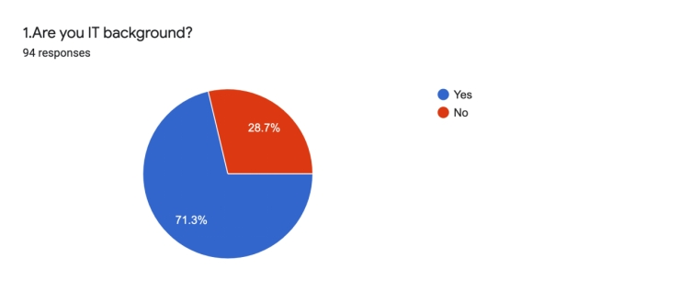

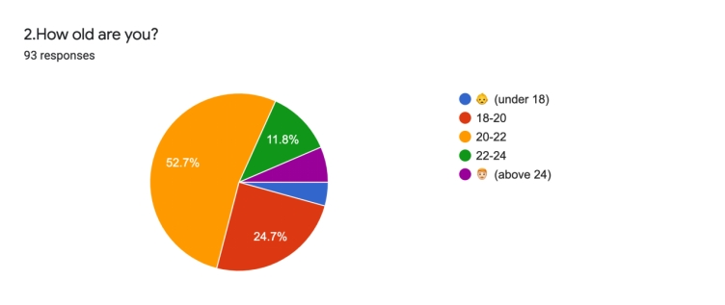

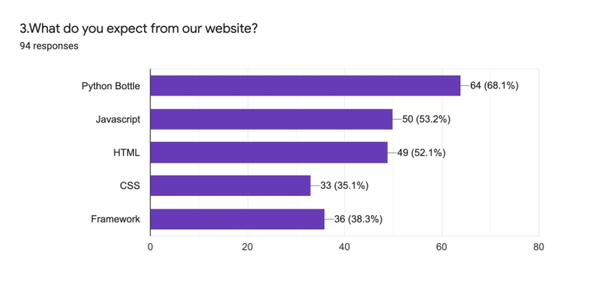

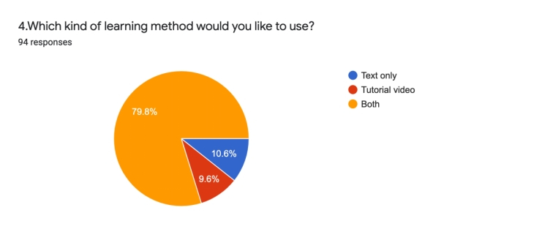

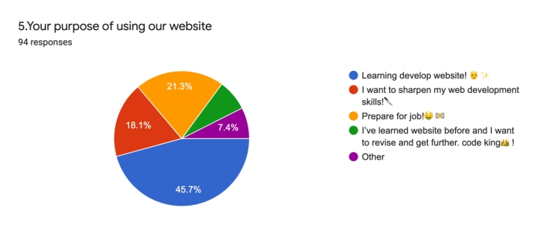

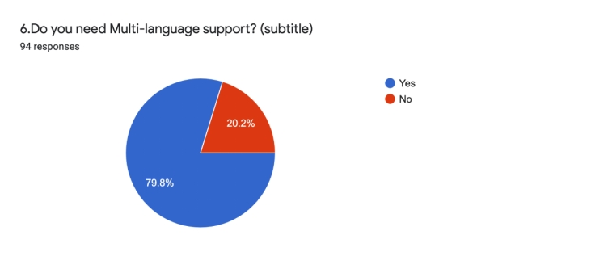

## Appendix D – card sorting result

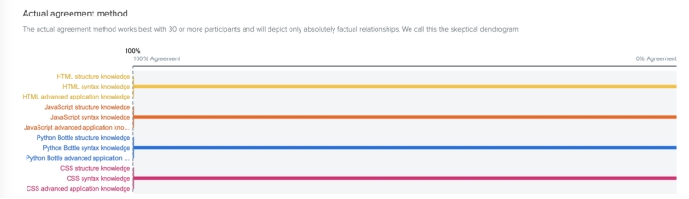

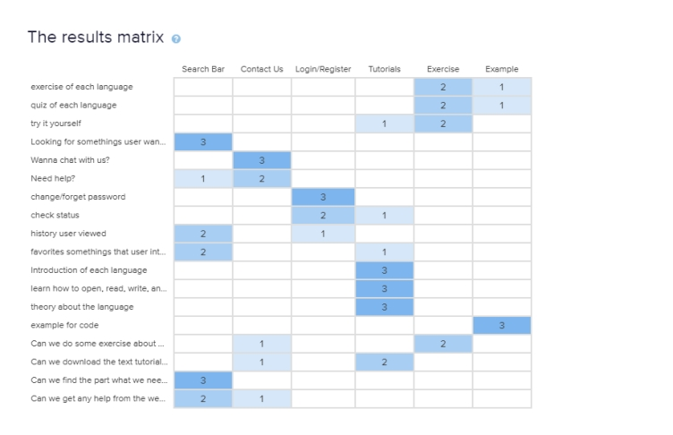

## Appendix E – wireframe

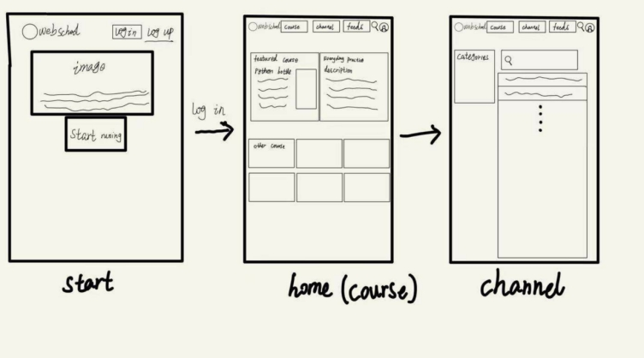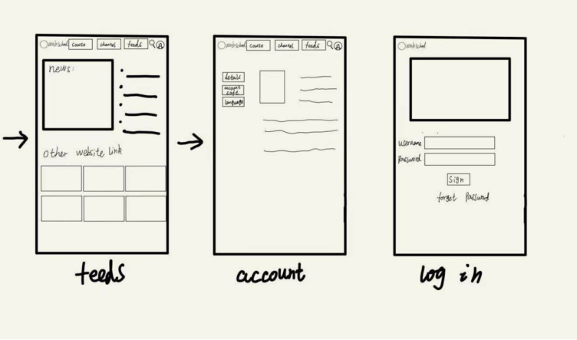

## Appendix F – First usability testing

### User - Estelle Wang

**Participant**

Name: Estelle Wang

Age: 21

Degree: Bachelor of Advanced Computing

Gender: Female (She/her)

|  |  |  |  |
| --- | --- | --- | --- |
|  | **Pages** | **User Response (Any issues?)** | **Additional Comments** |
| 1. | Sign up | None |  |
| 2. | Log in | None | Email login might be too long, we could use unikey |
| 3. | View Bottle course | None | Bottle image could be smaller |
| 4. | View JavaScript course | None | Could be set in higher resolution |
| 5. | View HTML practice | None |  |
| 6. | View Python practice | None |  |
| 7. | Message a user | None |  |
| 8. | View message history | Task set inappropriately since there is no message listed |  |
| 9. | View Forum | None |  |
| 10. | Manage profile | None |  |
| 11. | View Feeds | None |  |

**Interview Questions**

1. What are your general opinions on the website design?

Generally okay.

1. Which pages and specific elements do you think needs improvement?

Other course in the course page is confusing, there are four links to one page.

Featured courses other courses could be put in one page with featured courses prioritized.

1. Any features or functionalities you feel like is needed?

Nothing else :)

### User - Encheng Qu

**Participant**

Name: Encheng Qu

Age: 21

Degree: Bachelor of Software Engineering

Gender: Male (He/him)

|  |  |  |  |
| --- | --- | --- | --- |
|  | **Pages** | **User Response (Any issues?)** | **Additional Comments** |
| 1. | Sign up | None |  |
| 2. | Log in | None |  |
| 3. | View Bottle course | None | The font so big, img should be small |
| 4. | View JavaScript course | Should be add native | Could be set in higher resolution for pic. |
| 5. | View HTML practice | None | There are only questions without any tutorials. |
| 6. | View Python practice | None |  |
| 7. | Message a user | None |  |
| 8. | View message history | None |  |
| 9. | View Forum | None | Filter is not clear |
| 10. | Manage profile | None | Fonts could be different |
| 11. | View Feeds | None | Messy |

**Interview Questions**

1. What are your general opinions on the website design?

All good in structure and logic.

1. Which pages and specific elements do you think needs improvement?

Course Page needed be improved, cannot find what I need in time and effectively.

1. Any features or functionalities you feel like is needed?

No

### User - Shiyuan Li

**Participant**

Name: Shiyuan Li

Age: 20

Degree: Bachelor of Advanced Computing

Gender: Male (he/him)

|  |  |  |  |
| --- | --- | --- | --- |
|  | **Pages** | **User Response (Any issues?)** | **Additional Comments** |
| 1. | Sign up | No, pretty good |  |
| 2. | Log in | No problem |  |
| 3. | View Bottle course | Good | Bottle logo is too big |
| 4. | View JavaScript course | The size of the font in the menu is too small | It will be better if the menu can be hided. |
| 5. | View HTML practice | Good |  |
| 6. | View Python practice | The size of the font in the menu is too small |  |
| 7. | Message a user |  | Should improve this function and make DM achievable |
| 8. | View message history |  |  |
| 9. | View Forum |  |  |
| 10. | Manage profile | Avatar take too many places in this page |  |
| 11. | View Feeds | No subscribe button of daily news. |  |

**Interview Questions**

1. What are your general opinions on the website design?

Some defect exists, but mostly OK.

1. Which pages and specific elements do you think needs improvement?

Other course, Quiz and Tutorial buttons all goes to the same page, which is very confused. They can be combined, which will save place for another potential functional button.

1. Any features or functionalities you feel like is needed?

Subscribe button in Feeds.

### User – Tony

**Participant**

Name: Tony

Age: 21

Degree: Undergraduate

Gender: male

|  |  |  |  |
| --- | --- | --- | --- |
|  | **Pages** | **User Response (Any issues?)** | **Additional Comments** |
| 1. | Sign up | No, pretty good |  |
| 2. | Log in | No problem |  |
| 3. | View Bottle course | Good |  |
| 4. | View JavaScript course | Very good |  |
| 5. | View HTML practice | Good |  |
| 6. | View Python practice | Good |  |
| 7. | Message a user | Can’t use the message since I can’t type a word or DM with others and also cannot make a group talk. | Should improve this function and make DM achievable |
| 8. | View message history | Can’t use this function since I can’t use message |  |
| 9. | View Forum | I can only see one forum in this website, and I can click on the others |  |
| 10. | Manage profile | I can’t manage my profile, but I can check my profile | Give the authorize to manage my own profile |
| 11. | View Feeds | I can see the feeds, but I cannot click on them | Should be able to check multiple feeds |

**Interview Questions**

1. What are your general opinions on the website design?

Pretty good about log in and create account and also seeing course but the other functions are seemed not prepared enough.

1. Which pages and specific elements do you think needs improvement?

Message manage profile and feeds.

1. Any features or functionalities you feel like is needed?

Nothing needed to be added but to improvement those functions I talked above.

### User - Xiwen Zhang

**Participant**

Name: Xiwen Zhang

Age: 21

Degree: Bachelor of law

Gender: Female (She/her)

|  |  |  |  |
| --- | --- | --- | --- |
|  | Pages | User Response (Any issues?) | Additional Comments |
| 1. | Sign up | None |  |
| 2. | Log in | None | Better change words “email” to “username” |
| 3. | View discussion board | The participant chose the button channel | The image of button discussion and channel could be extremely similar |
| 4. | View course | The size of the font in the menu is too small | The button of the course like a course schedule |
| 5. | View HTML practice | None | There are only questions without any tutorials. |
| 6. | View CSS course | The participant tries to find backward button | Needs to add a back button, otherwise users have to go back to course pages and choose another course then go to CSS course, which is too complex. |
| 7. | Message a user | None | Same problem with q3 |
| 8. | View message history | None |  |
| 9. | Manage profile | None | None |
| 10. | View Feeds | None | The button of feeds is too ambiguous |

**Interview Questions**

1. What are your general opinions on the website design?

Too many buttons are ambiguous

1. Which pages and specific elements do you think needs improvement?

Website needs a back button

1. Any features or functionalities you feel like is needed?

Aesthetics design should be upgraded

## Appendix G – First usability testing

### User – Venna

**Participant**

Name: Venna

Age:19

Degree: Bachelor of Engineering

Gender: Female (She/Her)

|  |  |  |  |
| --- | --- | --- | --- |
|  | **Pages** | **User Response (Any issues?)** | **Additional Comments** |
| 1. | Sign up | None |  |
| 2. | Log in | None |  |
| 3. | View Bottle course | None |  |
| 4. | View JavaScript course | None |  |
| 5. | View HTML practice | None | ‘Practice & course’ could be larger to draw more attention |
| 6. | View Python practice | None |  |
| 7. | Message a user | None | Add friend button in channel page could be improved |
| 8. | View message history | None |  |
| 9. | View Forum | None |  |
| 10. | Manage profile | None | Has a little issue on locating |
| 11. | View Feeds | None | Need a record and load button to feel more natural |

**Interview Questions**

1. What are your general opinions on the website design?

* Search function could be only for course and practice & quiz
* Go-back button in feeds
* Adopted to Usyd canvas system, practice section could be embedded in related courses
* The colour theme in the feeds could be improved.

1. Which pages and specific elements do you think needs improvement?

Header in html course page has error (navigate to profile page)

1. Any features or functionalities you feel like is needed?

Share function with website screenshot downloaded or Website bookmark

### User - Christine (Yuwei)

**Participant**

Name: Christine (Yuwei)

Age:20

Degree: Bachelor of Science

Gender: Female (She/Her)

|  |  |  |  |
| --- | --- | --- | --- |
|  | **Pages** | **User Response (Any issues?)** | **Additional Comments** |
| 1. | Sign up | None | It is good. But what does a resetting password need? Feel like only a security question is not enough…. |
| 2. | Log in | None |  |
| 3. | View Bottle course | None | I have looked at all the courses and practices. It is well formatted. |
| 4. | View JavaScript course | None |  |
| 5. | View HTML practice | None |  |
| 6. | View Python practice | None |  |
| 7. | Message a user | None | Page 7 is so big that it cannot display on my side, even when I tried to zoom out. |
| 8. | View message history | None |  |
| 9. | View Forum | None |  |
| 10. | Manage profile | None |  |
| 11. | View Feeds | None |  |

**Interview Questions**

1. What are your general opinions on the website design?

I like the header, where I can (am oriented to?) jump to course, discussion, channel… very conveniently. The search bar also looks good, although I cannot use it now.

It is also convenient that I can view my profile at the top right.

1. Which pages and specific elements do you think needs improvement?

The total website is too full and a little bit messy. If there are some empty spaces, I personally will feel better. Also, I find the web page is not fixed, it can roll in horizontal direction. I will prefer a website with smaller font size and fixed horizontal direction. I notice that I can customise the font size by Setting. But It is a little bit weird.

Moreover, I find that if I am redirected to other pages, there is no immediate way if I want to go back.

1. Any features or functionalities you feel like is needed?

I think the functionalities are sufficient.

### User - Irene Qu

**Participant**

Name: Irene Qu

Age: 21

Degree: Bachelor of Software Engineering

Gender: Male (He/him)

|  |  |  |  |
| --- | --- | --- | --- |
|  | **Pages** | **User Response (Any issues?)** | **Additional Comments** |
| 1. | Sign up | None |  |
| 2. | Log in | None |  |
| 3. | View Bottle course | None |  |
| 4. | View JavaScript course | None |  |
| 5. | View HTML practice | None |  |
| 6. | View Python practice | None |  |
| 7. | Message a user | None |  |
| 8. | View message history | None |  |
| 9. | View Forum | None | Other thread cannot be clicked, and cannot reply the thread. |
| 10. | Manage profile | None |  |
| 11. | View Feeds | None |  |

**Interview Questions**

1. What are your general opinions on the website design?

All good in structure and logic.

1. Which pages and specific elements do you think needs improvement?
2. Any features or functionalities you feel like is needed?

No

### User - Sijia Yu

**Participant**

Name: Sijia Yu

Age: 22

Degree: Bachelor of Computer Science

Gender: Female

|  |  |  |  |
| --- | --- | --- | --- |
|  | **Pages** | **User Response (Any issues?)** | **Additional Comments** |
| 1. | Sign up | Good | Font size seems too large |
| 2. | Log in | Good |  |
| 3. | View Bottle course | Good |  |
| 4. | View JavaScript course | Good |  |
| 5. | View HTML practice | Good |  |
| 6. | View Python practice | Good |  |
| 7. | Message a user | Unable to type in anything yet | Users’ icon can be shown in the contact’s list. |
| 8. | View message history | Good |  |
| 9. | View Forum | The layout is good, but not able to switch to other forum windows | The comment box is a bit small compare to the content part. Users may feel uncomfortable if they want to type in long contents. |
| 10. | Manage profile | The ‘upload pic’ option is not available. | The ‘Moments’ section is unmeaningful, no explanation. |
| 11. | View Feeds | Good |  |

**Interview Questions**

1. What are your general opinions on the website design?

The font size of pages is not consistent, may cause users hard to read.

1. Which pages and specific elements do you think needs improvement?

The contents/icons of course & quiz home page seems a bit overlapping. Maybe try to use only one icon for each programming language and give choices for course and quiz under each language.

The icons of user can be added to the contacts list of chatting window, so that users can distinguish people easier.

1. Any features or functionalities you feel like is needed?

The website can add some functions to allow users to share some pages/articles/courses that they feel useful or interesting to their friends.

### User – Gaohao ming

**Participant**

Name: Gaohao ming

Age: 20

Degree: Bachelor of law

Gender: Female (She/Her)

|  |  |  |  |
| --- | --- | --- | --- |
|  | **Pages** | **User Response (Any issues?)** | **Additional Comments** |
| 1 | Sign up | None |  |
| 2 | Log in | None |  |
| 3 | View Bottle | None |  |
| 4 | course View  JavaScript course | None | Navigation have the same background colour with content |
| 5 | View HTML practice | None |  |
| 6 | View Python practice | None |  |
| 7 | Message a user | None |  |
| 8 | View message history | None |  |
| 9 | View Forum | None |  |
| 10 | Manage profile | None | Safety should in the setting |
| 11 | View Feeds | None |  |

**Interview Questions**

1. What are your general opinions on the website design?

All good in structure and logic.

1. Which pages and specific elements do you think needs improvement?

Navigation have the same background colour with content

1. Any features or functionalities you feel like is needed?

Some backgrounds colour should be change

## Appendix H – PACT Analysis

People

* Students from The University of Sydney
* Website admin(s)

Technologies

* Access to the Internet
* Input the keyword about the part of web development what they want
* View the tutorial material about what they want to learn
* Material came from the web-development-related courses from University
* Keyboard and mouse
* Tablet
* Smartphones

Activities

* Learn the basic skill of website development
* Discuss and solve problems with other developers

Contexts

* Related to web development skills and knowledge

## Appendix I – Graphical representation of group’s journey

